Execution of POC with eView Studio



Authors: | Phani Krishna P / Shaik Humera
Reviewer:
Date: | 19/05/2008
Document Version Number: | Version 1.0

Document History:
Version | AMENDMENT Date | Amendment Description
1.0

Table of Contents
Document History: 1
1.0 INTRODUCTION 3
1.1 Purpose of the document 3
1.2 Scope 3
1.3 Intended Audience 3
2.0 DEFINITIONS 3
3.0 Pre-requisites 4
4.0 Execution 4
4.1 Creation of eview application 4
4.2 Creation of Connectivity Map 6
4.3 Configure eview database 7
4.4 Configuring Environment and Deploying Project 8
4.5 Creating eView User Using Enterprise Manager 8
4.6 Using EDM (Enterprise Data Manager) for PatientView 9

INTRODUCTION

1.1 Purpose of the document
The purpose of this document is to get familiarize with the usage of eView Studio in the JCAPS suite.

1.2 Scope
This document provides step-by-step instructions for creating a master index application using eView Studio. It includes navigational information, functional instructions, and background information where required.
The scope of this document is limited to implementing a POC using eView studio.

1.3 Intended Audience
This document is intended for experienced JCAPS consultants who need to create a master index using eView Studio.

DEFINITIONS
Term | Use
eView Wizard | Wizard for defining “Enterprise Object” for which a single-view is desired  - Source systems specified from which System Objects will be collected  - System Object “surviving” fields which will make up a Single Best Record are selected  - Matching rules defined (e.g., fields to be matched are specified
Enterprise Data Manager | EDM is a web-based interface that allows you to monitor and maintain the data in your indexing application database. Most of the configurable attributes of the EDM are defined by information you specify in the eView Wizard, but you can use Enterprise Data Manager Configuration to further configure the EDM after you generate the indexing application Project. The EDM provides the ability to manually search for records; update, add, deactivate, and reactivate records; merge and unmerge records; view potential duplicates; and view comparisons of object records.

Pre-requisites
- In order to work with eView Studio, you only need to perform the eView Studio installation. To work with the eView Studio master index, a second component, an Oracle or SQL Server database, must be installed for any master indexes you create.

Execution
The scenario followed for workflow implementation using eView is as follows:
NOTE:
- The First scenario is like to add the new records.
- The second scenario is like to find potential duplicates.
- The third scenario is like to find matched records.
Create a New Project under the repository for this scenario. The Project is named as prjPatientView in this document.

Creation of eview application
- Right click on the project and select ‘New’ and choose ‘eview Application’.
- Name the application as PatientView.
- Add source system: HospitalA and HospitalB (any source system names can be used).
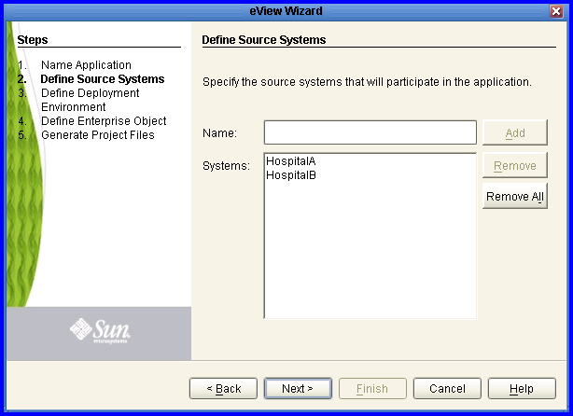
- Use default deployment environment properties.
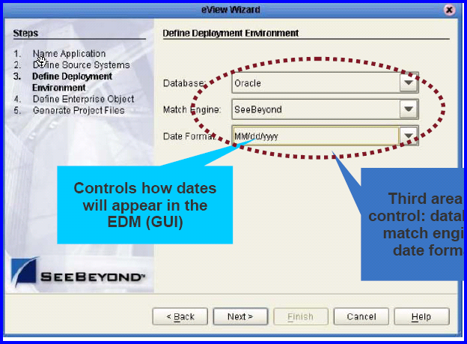
5) Create Enterprise Object “PatientView”
- Fields: SSN, FirstName, LastName, Age, and Sex.
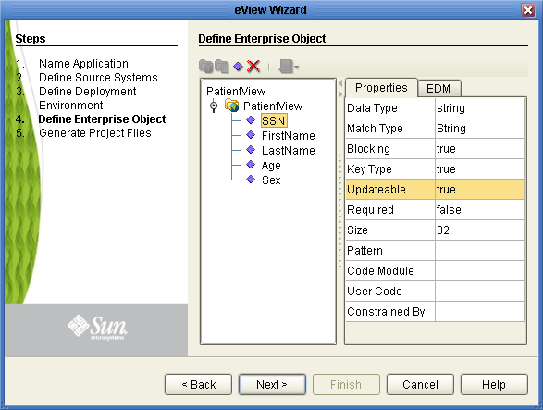
- In “Generate Project Files” screen, do not check “Generate the remaining eView application files now” and check “Finish”.
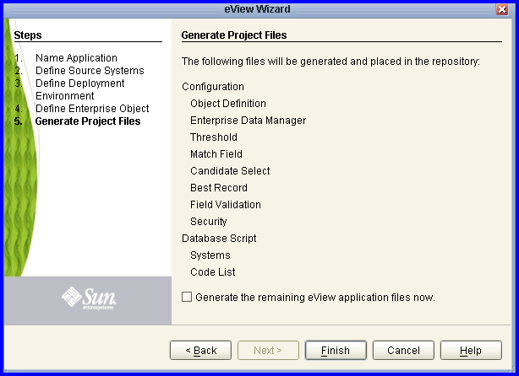

- Wait until the project descriptor files are generated
- Right-mouse click the eView application object “eView Application – PatientView” and selects “Generate”.
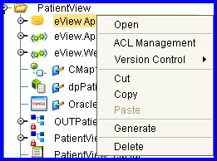

Creation of Connectivity Map
Create connectivity map for “eView.Web.Application-PatientView” and “eView.Application-PatientView”.

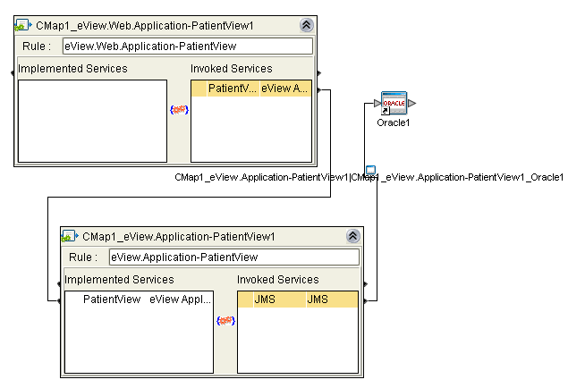

Configure eview database

- Create eView database user using your favorite SQL client.
Create user eviewtest identified by eviewtest;
Grant dba to eviewtest with admin option;
Grant select any table to eviewtest with admin option;
Grant create user to eviewtest with admin option;
- Right mouse click “Database Script” folder, select “Properties” and enter eView database user information.
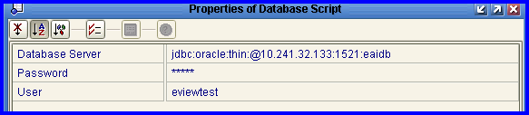
- Right mouse click “Create PatientView database” and select “Run”.
- Right mouse click “Code List” and select “Run”.
- Right mouse click “Systems” and select “Run”.
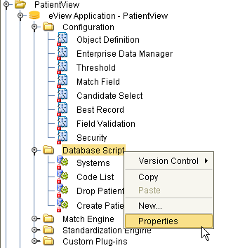

Configuring Environment and Deploying Project

Switch to Environment Explorer.
2. Create or re-use an environment with the following components:
  - LogicalHost
  - Integration Server
  - Oracle external system using “eviewtest” database user.
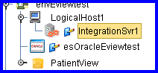

- Create Deployment profile

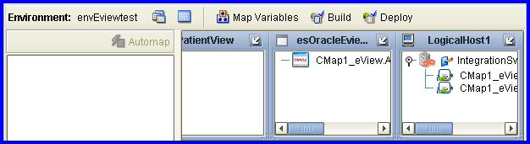

3. Bulid and deploy the project.

Creating eView User Using Enterprise Manager

Go to Integration Server Administration page (via Enterprise Manager).Create run-time user “eview”. Set group list to “eView.Admin”, which gives the user administrator privilege for eView applications.
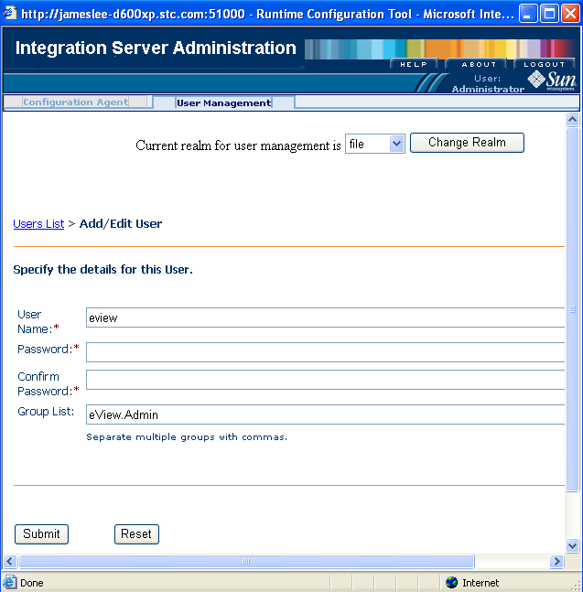

Using EDM (Enterprise Data Manager) for PatientView

  - Access EDM at http://logocalhost:port /prjnameedm as http://10.238.112.207:38001/PatientViewedm where 10.238.112.207 is logical host used and port is 38001.

  - Login in as run-time user “eview”.

  - Select “Create System Record” tab.

  - Enter system record fields and click “Add System Record”.

  - Add values and commit

System: HospitalA
Local ID: 111-111-1111
Enter local record fields and click “Commit”.
SSN: 123-45-6789
First Name: James
Last Name: Lee
Age: 21
Gender: M

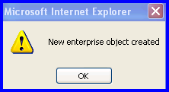

Enter new record.
System: HospitalB
Local ID: 222-222-2222.

For Assumed Match:

Enter local record fields and click “Commit”.
SSN: 123-45-6788
First Name: Jimmy
Last Name: Lee
Age: 21
Gender: M
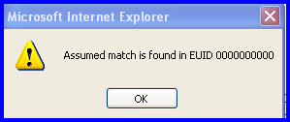

Enter new record
System: HospitalB
Local ID: 444-444-4444.

For Potential Duplicates:

Enter local record fields and click “Commit”.(Potential Duplicate)
SSN: 123-45-6788
First Name: Jimmy
Last Name: Lee
Age: 21
Gender: M

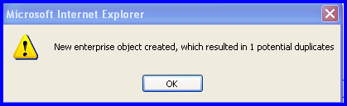

For Matched Review:

- Select “Matching Review” tab.
“Search for Potential Duplicates”
Create Date From: <today’s date>
To Create Date: <today’s date>

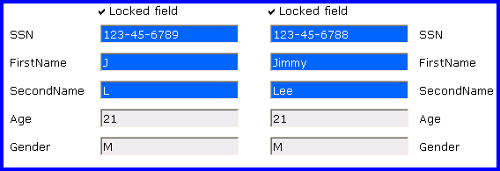

Generate the weekly Activity report:

